

Model 697

AC/DC CURRENT CLAMP
INSTRUCTION MANUAL
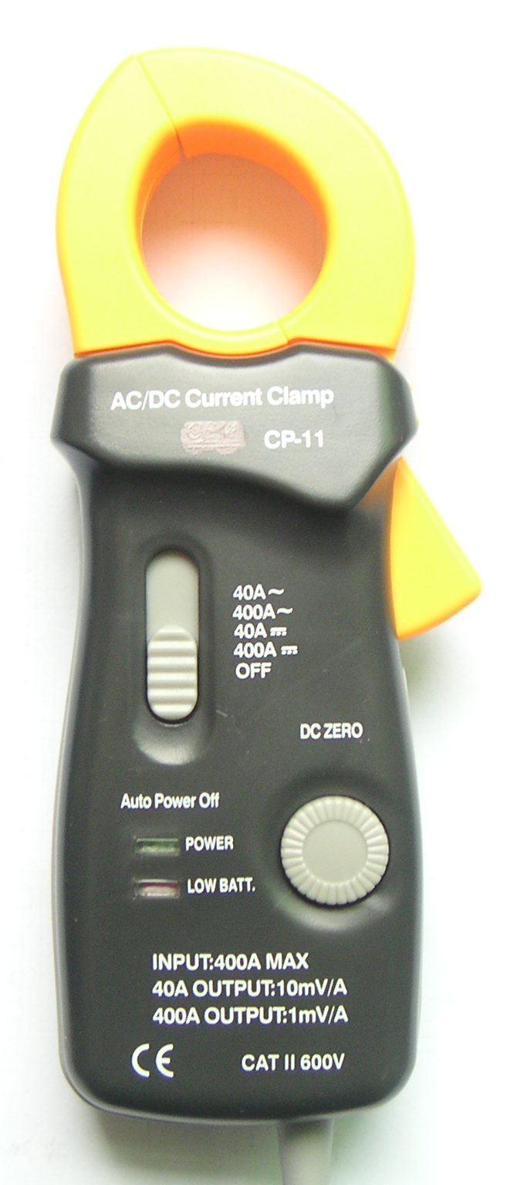
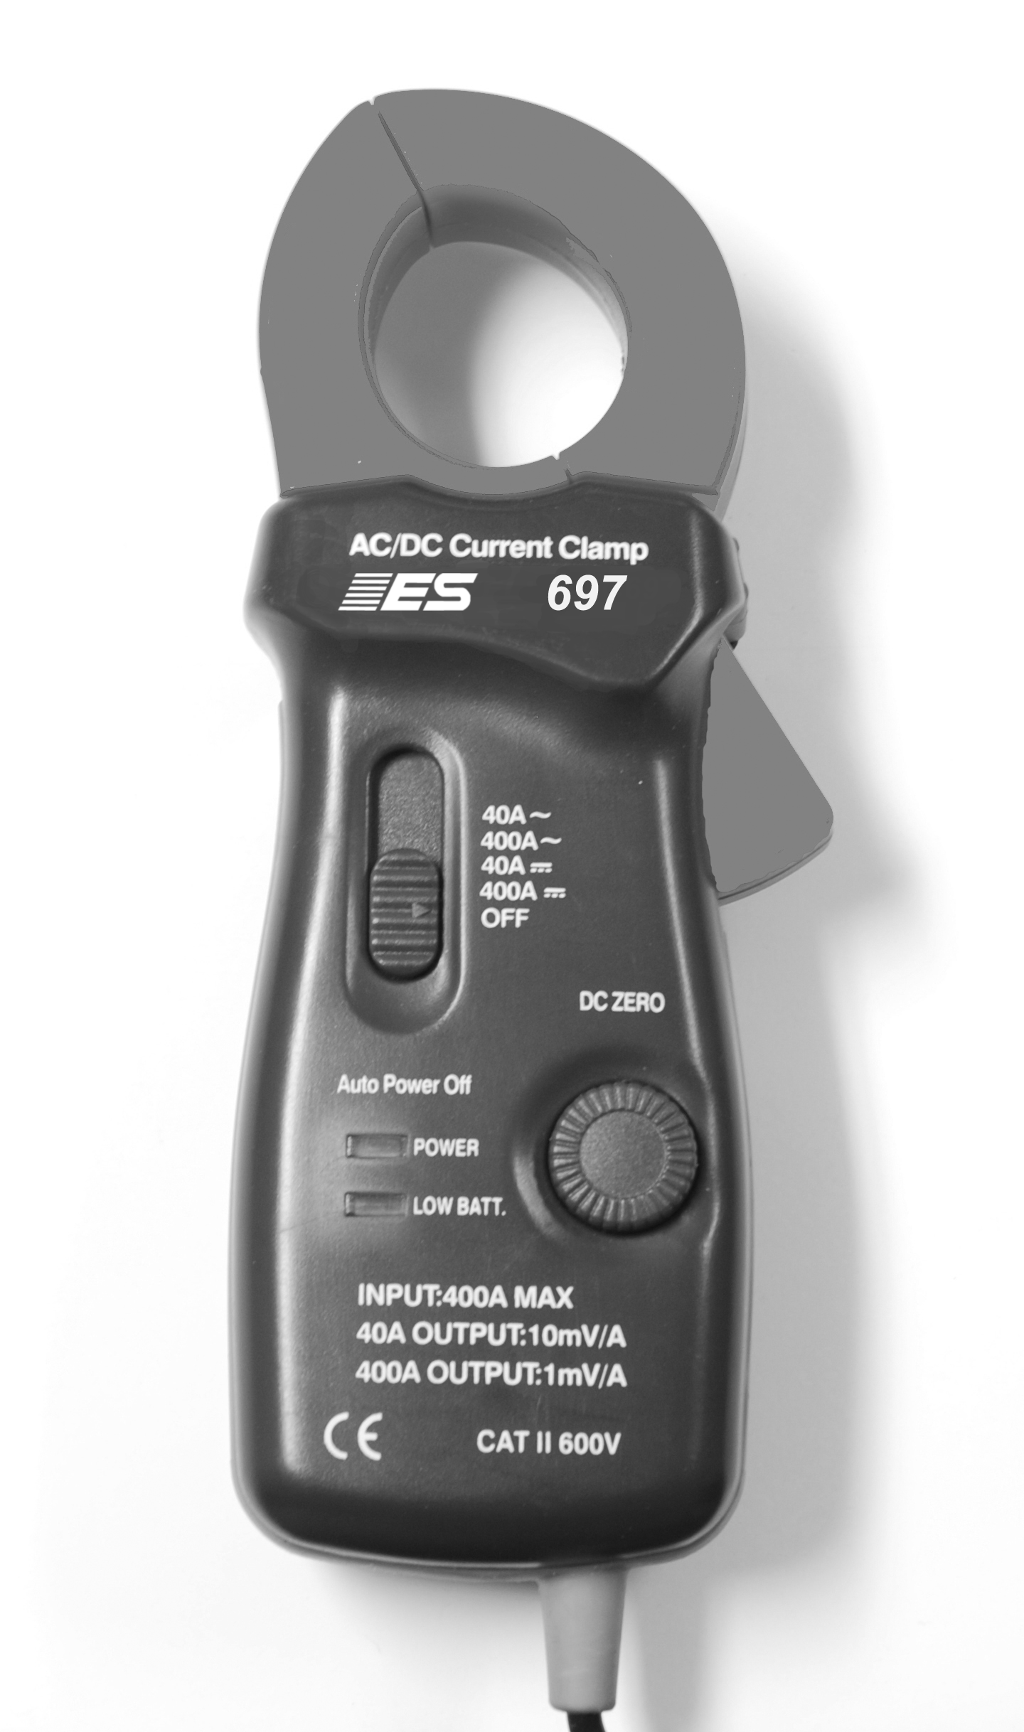

Member


INTRODUCTION
The 697 AC/DC Current Clamp is a transducer which will allow your multimeter to measure electrical current up to 400 amperes AC/DC. When measuring current with this clamp, there is no need to break the circuit or to pierce any wire insulation. When measuring DC current, zero adjustment is made with the “one touch” DC zero button.
APPLICATION PROCEDURES
- Insert the black banana plug into the COM jack and the red banana plug into the V-Ωjack of any multimeter with a minimum input impedance of 10k ohms.
- Set the power switch from “OFF” to the desired range, 40A (output: 10mV/A) or 400A (1mV/A) position. The green LED will light to indicate that the clamp is turned on.
- For current measurement below 40A, set 697 to the 40A range. Set the multimeter to the 200mV or 400mV AC range for AC current measurements, or 200mV or 400mV DC range for DC current measurements (note: most auto-ranging DMM’s default to mV range). If the measured current exceeds 40A, set the unit to 400A range.
- When performing DC current measurement, always push the zero adjustment button on the clamp until the multimeter reads zero.
- Clamp the jaws around the current-carrying conductor and interpret the reading according to Step 3 above.
- When 697 is set to the 40A range, be aware of the conversion factor of Amps to Millivolts. For example, if the multimeter reads 100mV, the measured current is 100mV/(10mV/A)=10A.
- When 697 is set to the 400A range, the reading is straight Millivolts to amps. For example, if the multimeter reads 50mV, the measured current is 50mV/(1mV/A)=50A.

APPLICATION NOTES
- When measuring DC current, the output is positive when the current flows from the upside to the underside of the clamp. The red banana plug is positive.
- When measuring DC currents, a hysteresis effect can occur so that it is impossible to zero the clamp properly. To eliminate this effect, open and close the jaws several times and push zero adjustment button.

OPERATOR SAFETY
- Do not clamp around conductors with voltages equal to or exceeding 300V DC or 240V rms AC.
- To avoid physical injury, measurements on bare conductors or conductors with cracked or frayed insulator are forbidden.

SPECIFICATIONS
GENERAL
Captured Conductor Size: Φ20mm maximum
Low Battery Indictor: Red LED light
Operating Temperature: 0°C to 50°C, 70% R.H.
Storage Temperature: -20°C to +70°C, 80% R.H.
Battery Type: 9V DC NEDA 1604, 6F22, 006P
Battery Life: 80 hours typical with alkaline
Weight: 240g typical
Dimensions: 175mm(H)×70mm(W) ×38mm(D)
Output: banana plug

ELECTRICAL (At 23±5°C, 70% R.H. maximum)

Effective Measurement Range
40A (output: 10mV/A): DC or rms AC for 200mV or 400mV range of the multimter.
400A (output: 1mV/A): DC or rms AC for 400mV range of the multimeter.

Accuracy
Current Clamp Accuracy:
DCA range: 40A
0~20.00ADC: ± (3.5% +6digits)
20.00~40.00ADC: ± (4% + 10 digits)

DC range :400A
0~300.0ADC: ± (3.5% +6digits)
300.0~400.0ADC: ± (4.5% + 6 digits)

ACA range: 40A(50/60Hz)
0~20.00AAC: ± (4.0% +10digits)
20.00~40.00AAC: ± (5% + 10 digits)

ACA range: 400A(50/60Hz)
0~300.0ADC: ± (4.5% +10digits)
300.0~400.0ADC: ± (5% + 10 digits)


SAFETY INFORMATION
The instrument complies with class II, overvoltage CAT II - 600V of the EN 61010-1, and EN 61010-2-032 stardards. Pollution degree 2 in accordance with IEC 664 indoor use. If the equipment is used in a manner not specified, the protection provided by the equipment may be impaired.

WARRANTY INFORMATION:
This product is warranted to be free of defects for one year. If this product fails during the first 12 months due to faulty material or workmanship, it will be replaced or repaired free of charge, at the discretion of the manufacturer.

NOTE: this one year warranty does not cover accidental or intentional abuse.

For warranty service and coverage, please return this product to your supplier for processing and evaluation. OR, return it directly to:
Electronic Specialties, Inc.
139 Elizabeth Ln.
Genoa City, WI 53128
262-279-1400

Defective units being returned to your supplier or to the factory should include proof of purchase date.

Any testers that do not function due to misuse or abuse will be subject to “out of warranty service charges”.

For more interesting and time saving products,

please go to:

www.esitest.com

Or call 800-227-1603 for a free catalog!

